FIT5047 1st Semester 2018

Assignment 2

**Student Name: Chuangfu Xie**

**Student ID: 27771539**

**Q1.**

1. **Set up decision network in Netica**

Given by 3 options, namely option 1, option 2, option 3, all options are group as a decision note with 3 states:

1. Option 1 denoted as ‘Op1’ – going to do option 1.
2. Option 2 denoted as ‘Op2’ – going to do option 2.
3. Option 3 denoted as ‘Op3’ – going to do option 3.

“Decision” decision node setting as shown follow:

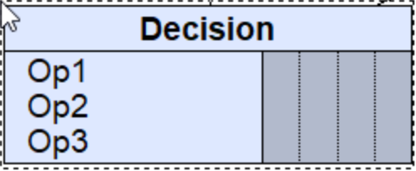

While, as option 2 and option 3 both link to mining decision, so we have Mining decision note with 2 states:

1. Mine – going to mine A
2. NotMine – not going to mine A

“Mining” decision node setting as shown follow:

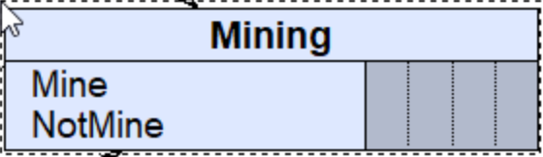

Now, as information provided, material A with probability of 50% will be worth $20000, and thus with another 50% that will be worth nothing ($0). Then we set up node “A has value” with 2 states:

1. True – A is valuable.
2. False – A is worth nothing.

“A has value” node setting as shown follow:

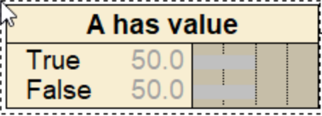

Further, consultant with 70% would say “A is present” and 30% say the opposite. Based on what she says, her predict that A is present, with 70% being correct and 30% being incorrect, while saying A is not present with 29/30 (96.67%) being correct and 1/30 (3.33%) being incorrect. Hence, we can set up node “Material A” based on the condition node “Consultant says”. Detailed setting as shown follow:

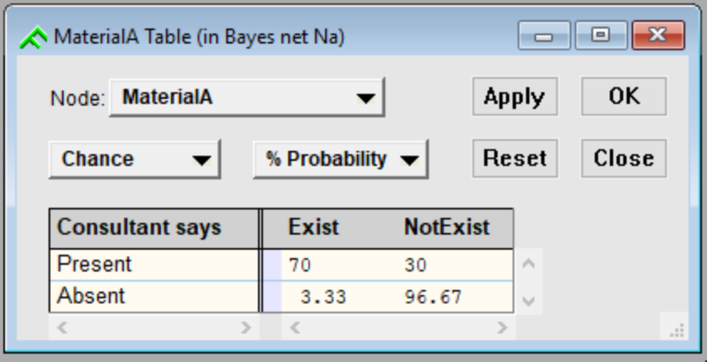

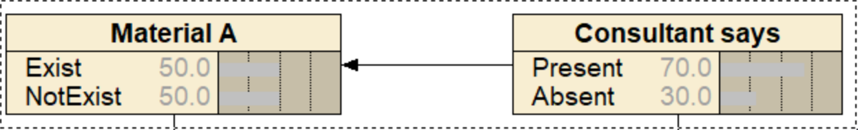

On the other hand, decision about mining or not defers when different options are choosing, there are 2 scenarios:

1. When we choose to do option 1, we do nothing.
2. When we choose to do option 2, no matter what consultant says, we will mine the material
3. When we choose to do option 3, mining decision is based on what consultant recommend, thus
   1. Consultant says A present, we do mining.
   2. Consultant says A is not present, we do nothing (not mining).

As explained above, “Mining” decision node is based on “Decision” decision node. Also, “Mining” decision node is based on “Consultant say” node. Relationship and setting are shown as follow:

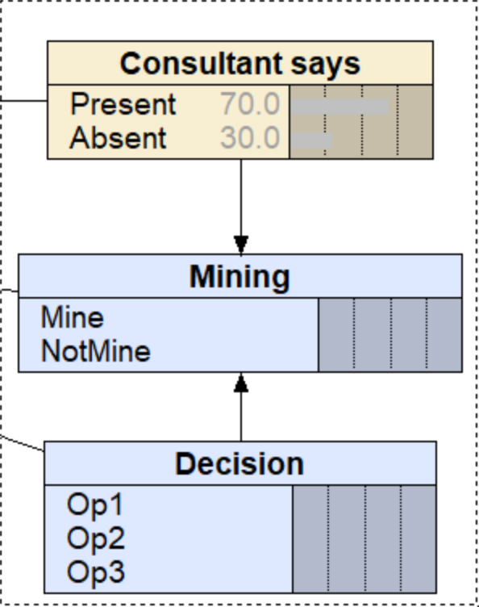

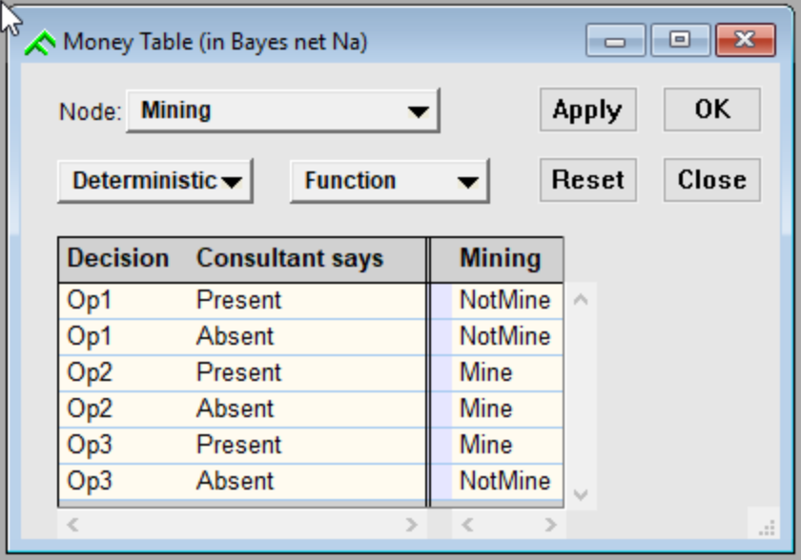

Now, we create a utility function named “Profit”. Under particular option chose, we have positive numeric value indicated profit earn if profit was made. Otherwise, negative value indicates we lose money. Follow all the information we know, “A has value”, “Material A”, “Mining” and “Decision” have relationship with utility:

1. If we choose option 1, nothing happens so that the utility under this option 1 will be given 0.
2. If we choose option 2, we insist on mining no matter what consultant say. As we don’t consider what situation would be like if we don’t mine, we give value 0 to utility to all “not mine” scenario under option 2. thus:
   1. When material A exist, if A has value, we have $20000-$10000, that is $10000 profit. Otherwise, we lose $10000 money on mining
   2. If material A doesn’t exist, no matter A is valuable or not, we lose $10000 money on mining
3. If we choose option 3, we mine based on what consultant says. However, what really matter is whether A exists or not (i.e. what will affect utility value is based on whether A exist or not), because whether we mine or not is equivalent to the statement that consultant made. Thus, we change our way to consider A exist or not:
   1. We mine and find A exist:
      1. A is valuable: $20000-$1000-$10000=$9000
      2. A is worthless: $-11000
   2. We mine and find A doesn’t exist, then no matter A is valuable or not, we lose $11000
   3. We don’t mine because consultant says A is not present. The only lose will be the spend on consultant, that is, $1000, no matter A in fact exist or not, or whether A is valuable.

The setting is shown as follow:

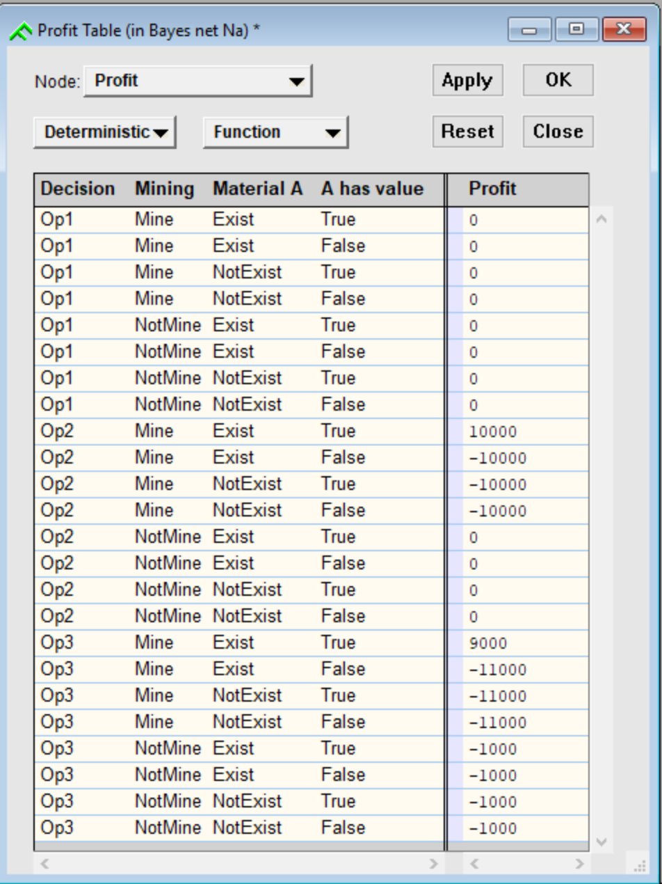

The entire decision network is shown as follow:

1. before compiled:

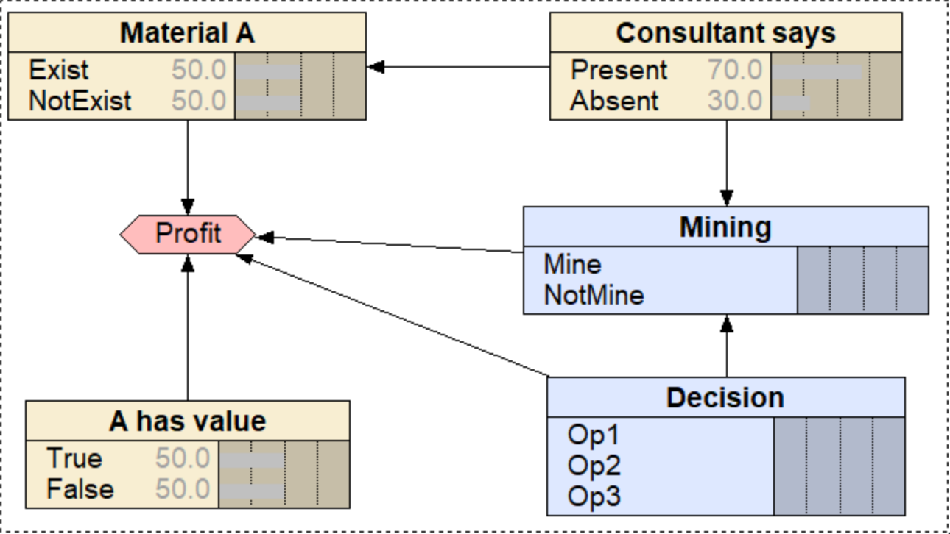

1. After compiled:

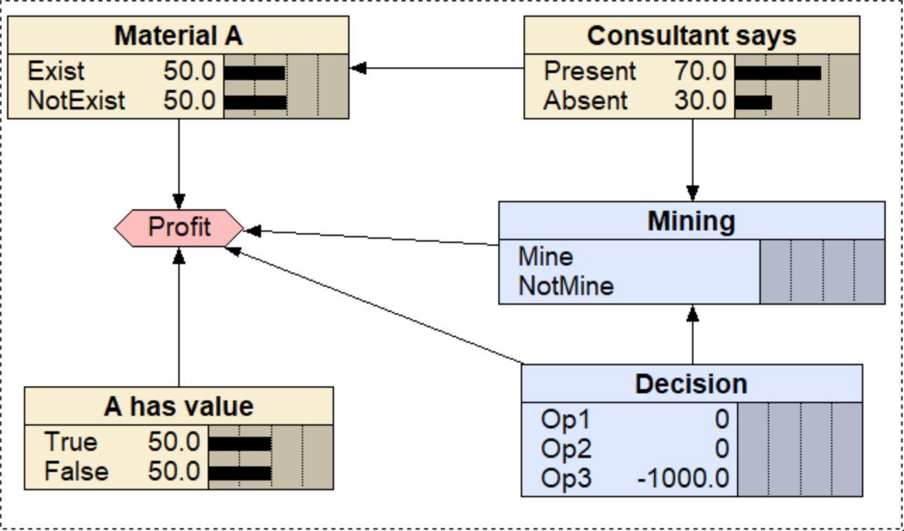

Option choosing:

1. If given evidence that proving A exactly is valuable:

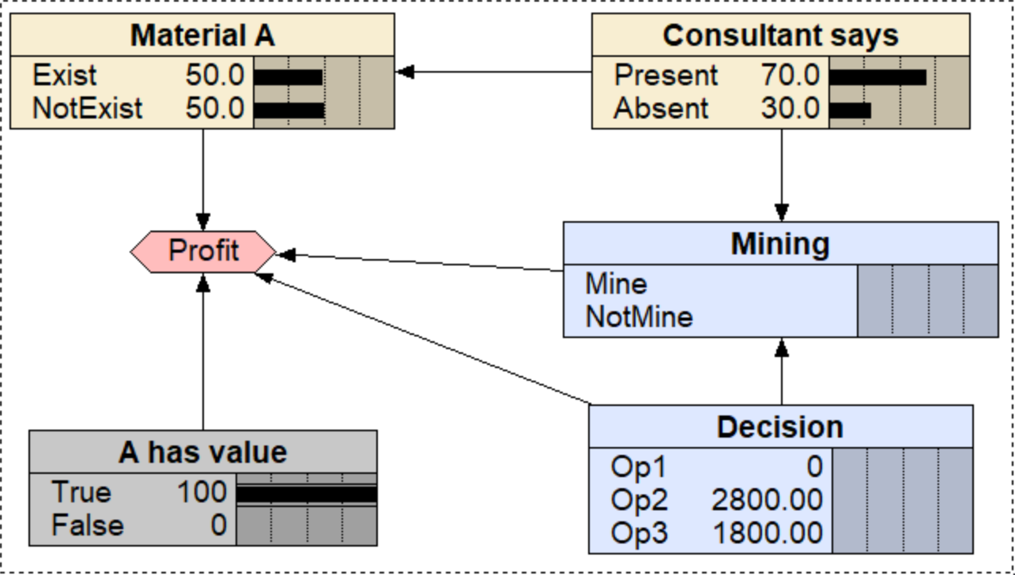

We will choose option 2, since the profit it made ($2800) is greater than option 1 ($0) and option 3 ($1800).

1. If given evidence that proving A exactly is worthless, in our common sense, we don’t have to pay money to get nothing. Thus, the only option for us is to choose option 1, to do nothing.
2. If given evidence that A material must exist:

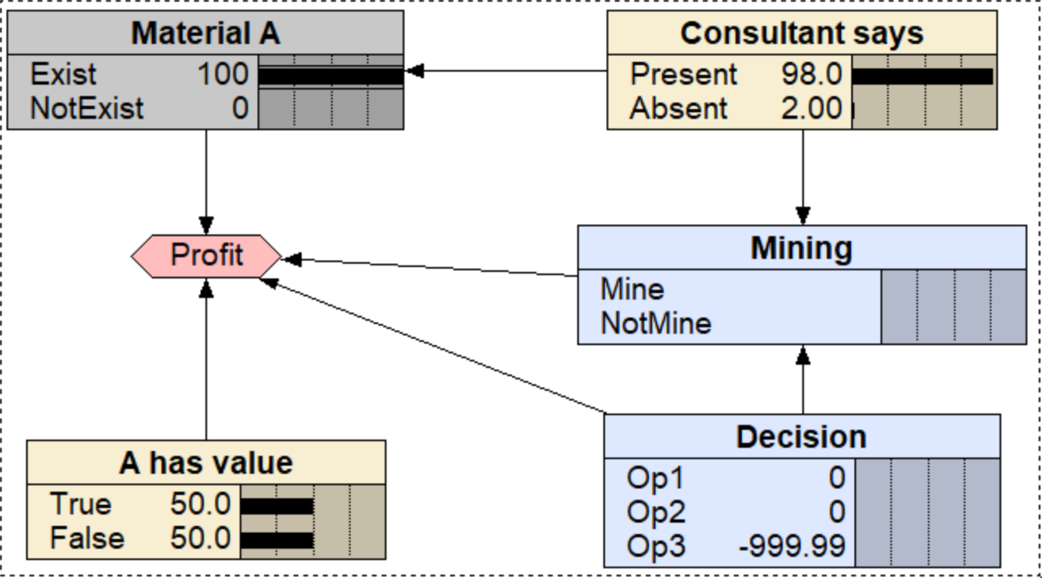

Then we can say, we won’t choose option 3 as we don’t need any consultant since the evidence already give that information. However, we still need more information to decide whether to choose option 1 or 2, so we assume that another evidence is given that A is valuable for sure:

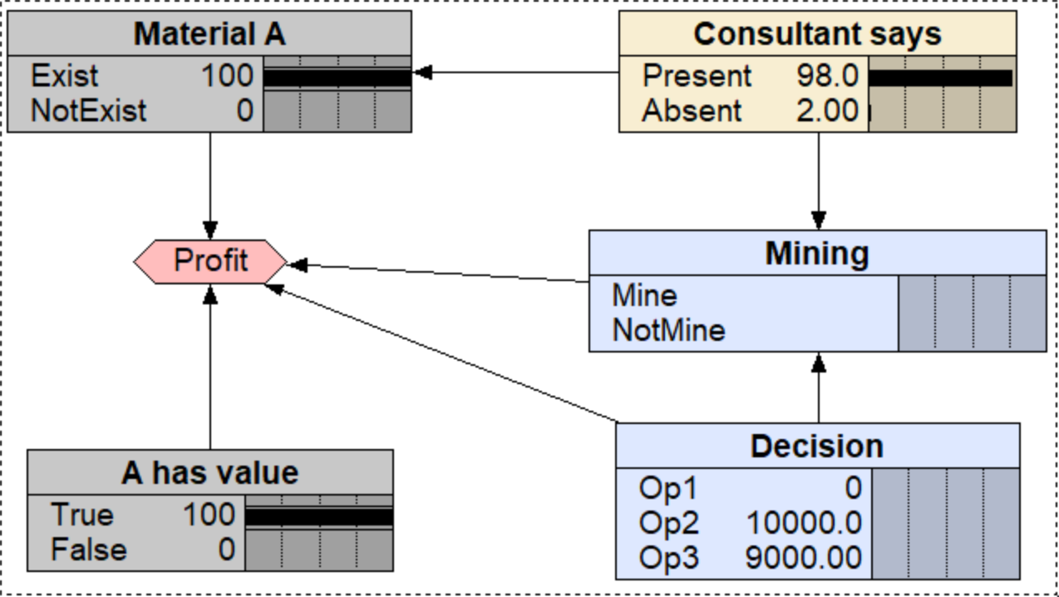

Hence, we choose option 2 (don’t bother spending $1000 to consult).

1. If given evident that A must be valuable, and consultant say A is present:

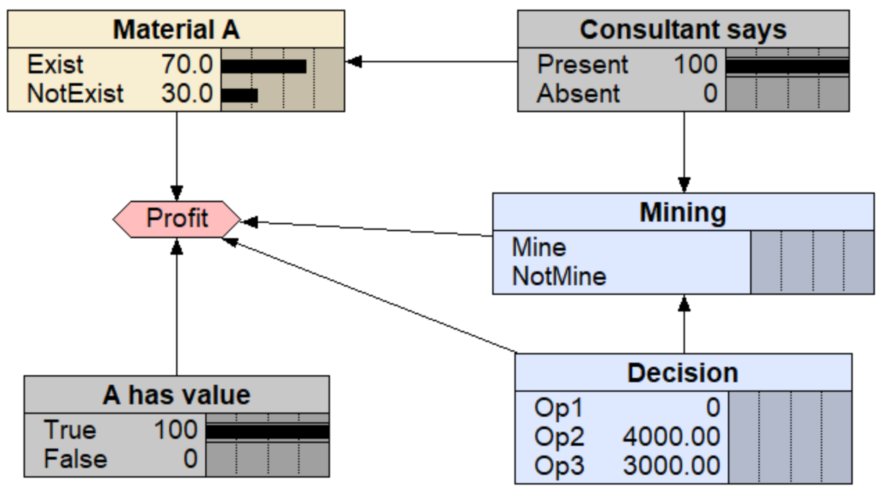

Now we have 2 options: option 2 with $4000 profit while option 3 with $3000 profit. Considering that when we choose option 2, we do mine regardless of what consultant say. On the other hand, If we choose option 3, as she said A is present, we mine. However, the profit we made is $1000 less than option 2, that is, the cost of consultation. Hence, we choose option 2.

1b.

Q3.

3a.

1 for TRUE, 0 for FALSE

XOR(0,0) = 0; XOR(1,1) = 0; XOR(0,1) = 1; XOR(1,0) = 1;

|  |  |  |  |  |  |  |  |
| --- | --- | --- | --- | --- | --- | --- | --- |
| No | a | b | c | d | e |  | y |
| 1 | 1 | 0 | 0 | 0 | 0 | **XOR(1**,**XOR(**0,**XOR(**0,**XOR(**0,0**))))** | 1 |
| 2 | 1 | 0 | 1 | 0 | 0 | **XOR(1**,**XOR(**0,**XOR(**1,**XOR(**0,0**))))** | 0 |
| 3 | 1 | 0 | 0 | 1 | 0 | **XOR(1**,**XOR(**0,**XOR(**0,**XOR(**1,0**))))** | 0 |
| 4 | 1 | 0 | 1 | 1 | 0 | **XOR(1**,**XOR(**0,**XOR(**1,**XOR(**1,0**))))** | 1 |
| 5 | 1 | 0 | 0 | 0 | 1 | **XOR(1**,**XOR(**0,**XOR(**0,**XOR(**0,1**))))** | 0 |
| 6 | 1 | 0 | 1 | 0 | 1 | **XOR(1**,**XOR(**0,**XOR(**1,**XOR(**0,1**))))** | 1 |
| 7 | 1 | 0 | 0 | 1 | 1 | **XOR(1**,**XOR(**0,**XOR(**0,**XOR(**1,1**))))** | 1 |
| 8 | 1 | 0 | 1 | 1 | 1 | **XOR(1**,**XOR(**0,**XOR(**1,**XOR(**1,1**))))** | 0 |
| 9 | 0 | 1 | 0 | 0 | 0 | **XOR(0**,**XOR(**1,**XOR(**0,**XOR(**0,0**))))** | 1 |
| 10 | 0 | 1 | 1 | 0 | 0 | **XOR(0**,**XOR(**1,**XOR(**1,**XOR(**0,0**))))** | 0 |
| 11 | 0 | 1 | 0 | 1 | 0 | **XOR(0**,**XOR(**1,**XOR(**0,**XOR(**1,0**))))** | 0 |
| 12 | 0 | 1 | 1 | 1 | 0 | **XOR(0**,**XOR(**1,**XOR(**1,**XOR(**1,0**))))** | 1 |
| 13 | 0 | 1 | 0 | 0 | 1 | **XOR(0**,**XOR(**1,**XOR(**0,**XOR(**0,1**))))** | 0 |
| 14 | 0 | 1 | 1 | 0 | 1 | **XOR(0**,**XOR(**1,**XOR(**1,**XOR(**0,1**))))** | 1 |
| 15 | 0 | 1 | 0 | 1 | 1 | **XOR(0**,**XOR(**1,**XOR(**0,**XOR(**1,1**))))** | 1 |
| 16 | 0 | 1 | 1 | 1 | 1 | **XOR(0**,**XOR(**1,**XOR(**1,**XOR(**1,1**))))** | 0 |
| 17 | 0 | 0 | 0 | 0 | 0 | **XOR(0**,**XOR(**0,**XOR(**0,**XOR(**0,0**))))** | 0 |
| 18 | 0 | 0 | 1 | 0 | 0 | **XOR(0**,**XOR(**0,**XOR(**1,**XOR(**0,0**))))** | 1 |
| 19 | 0 | 0 | 0 | 1 | 0 | **XOR(0**,**XOR(**0,**XOR(**0,**XOR(**1,0**))))** | 1 |
| 20 | 0 | 0 | 1 | 1 | 0 | **XOR(0**,**XOR(**0,**XOR(**1,**XOR(**1,0**))))** | 0 |
| 21 | 0 | 0 | 0 | 0 | 1 | **XOR(0**,**XOR(**0,**XOR(**0,**XOR(**0,1**))))** | 1 |
| 22 | 0 | 0 | 1 | 0 | 1 | **XOR(0**,**XOR(**0,**XOR(**1,**XOR(**0,1**))))** | 0 |
| 23 | 0 | 0 | 0 | 1 | 1 | **XOR(0**,**XOR(**0,**XOR(**0,**XOR(**1,1**))))** | 0 |
| 24 | 0 | 0 | 1 | 1 | 1 | **XOR(0**,**XOR(**0,**XOR(**1,**XOR(**1,1**))))** | 1 |
| 25 | 1 | 1 | 0 | 0 | 0 | **XOR(1**,**XOR(**1,**XOR(**0,**XOR(**0,0**))))** | 0 |
| 26 | 1 | 1 | 1 | 0 | 0 | **XOR(1**,**XOR(**1,**XOR(**1,**XOR(**0,0**))))** | 1 |
| 27 | 1 | 1 | 0 | 1 | 0 | **XOR(1**,**XOR(**1,**XOR(**0,**XOR(**1,0**))))** | 1 |
| 28 | 1 | 1 | 1 | 1 | 0 | **XOR(1**,**XOR(**1,**XOR(**1,**XOR(**1,0**))))** | 0 |
| 29 | 1 | 1 | 0 | 0 | 1 | **XOR(1**,**XOR(**1,**XOR(**0,**XOR(**0,1**))))** | 1 |
| 30 | 1 | 1 | 1 | 0 | 1 | **XOR(1**,**XOR(**1,**XOR(**1,**XOR(**0,1**))))** | 0 |
| 31 | 1 | 1 | 0 | 1 | 1 | **XOR(1**,**XOR(**1,**XOR(**0,**XOR(**1,1**))))** | 0 |
| 32 | 1 | 1 | 1 | 1 | 1 | **XOR(1**,**XOR(**1,**XOR(**1,**XOR(**1,1**))))** | 1 |

3b.

As the data we use for this section, each data of which is consist of 5 attributes (namely a, b, c, d, e) and 1 output which is y. Due to the nature of our data, the value of y basically is follow the XOR:

|  |  |  |
| --- | --- | --- |
| a  b | T | F |
| T | F | T |
| F | T | F |

As illustrated above, XOR data cannot be classified: it is not linearly separable.

By the definition of XOR, with multiple variables, each two variables yield an output which will be the input of another XOR formula, such as:

y = XOR(a, b, c, d, e)=XOR(a,XOR(b,XOR(c,XOR(d,e))))